CH.MADHULIKA_2520090056
SKILL WEEK-3
STORED PROCEDURES
- PROCEDURE TO DISPLAY ALL CUSTOMERS
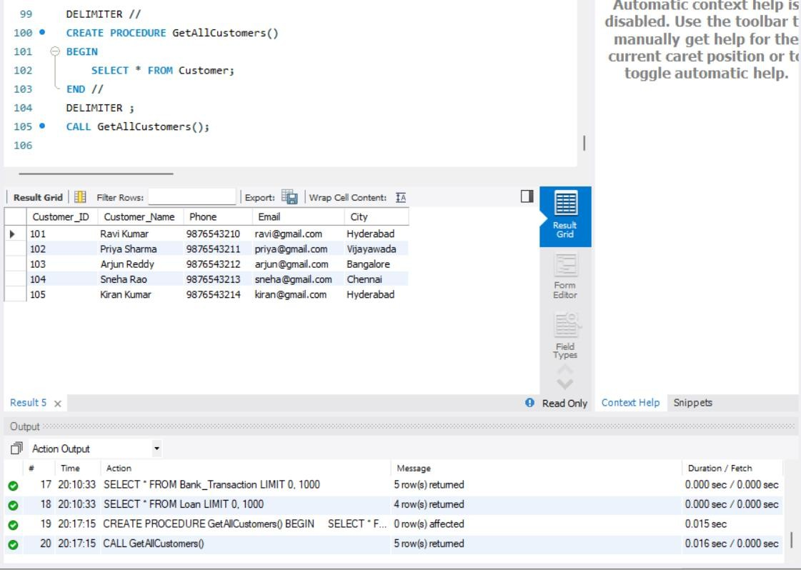
- PROCEDURE TO DISPLAY ACCOUNT DETAILS FOR A GIVEN ACCOUNT NUMBER
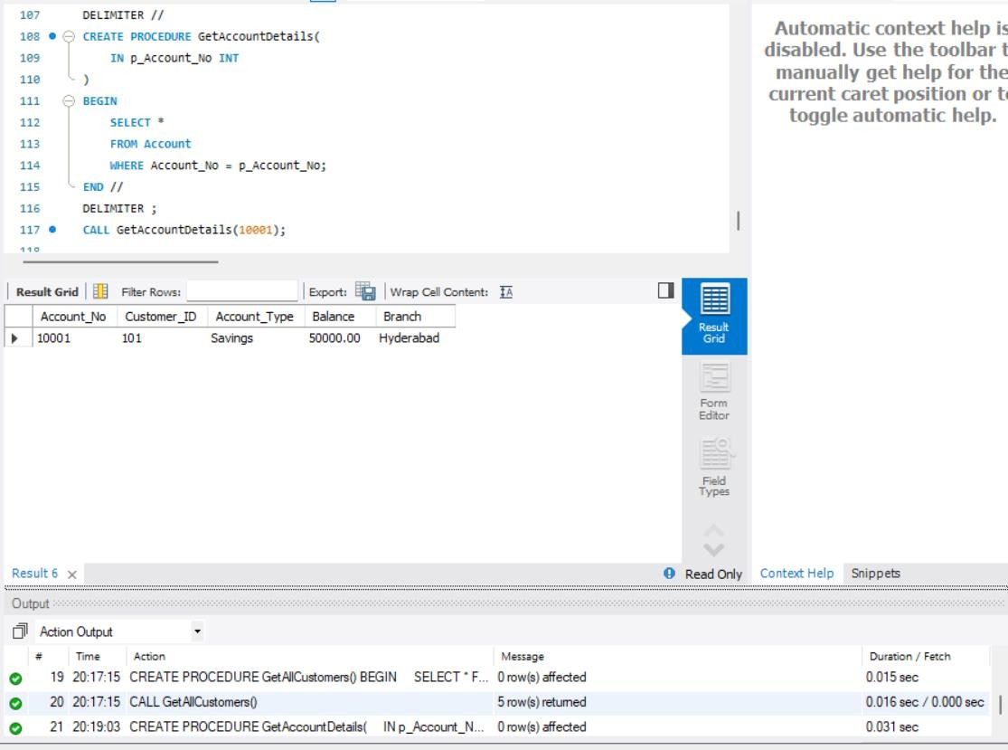

- PROCEDURE TO FIND CUSTOMER ACCOUNTS

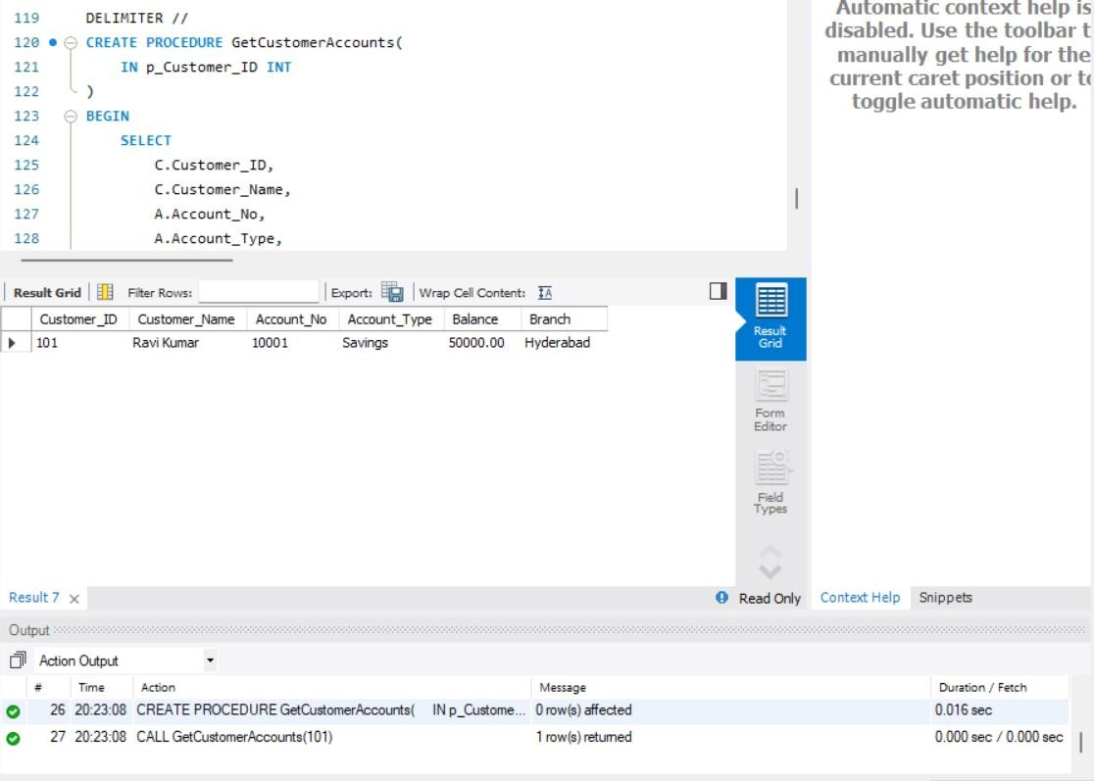
- PROCEDURE TO DEPOSIT MONEY
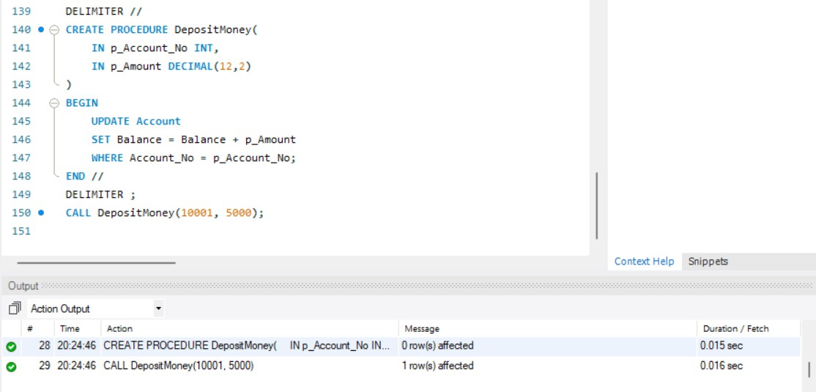

- PROCEDURE TO WITHDRAW MONEY
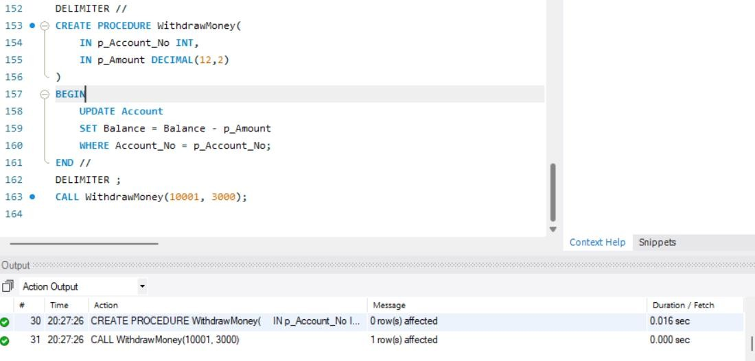
- TRIGGER – PREVENT NEGATIVE BALANCE
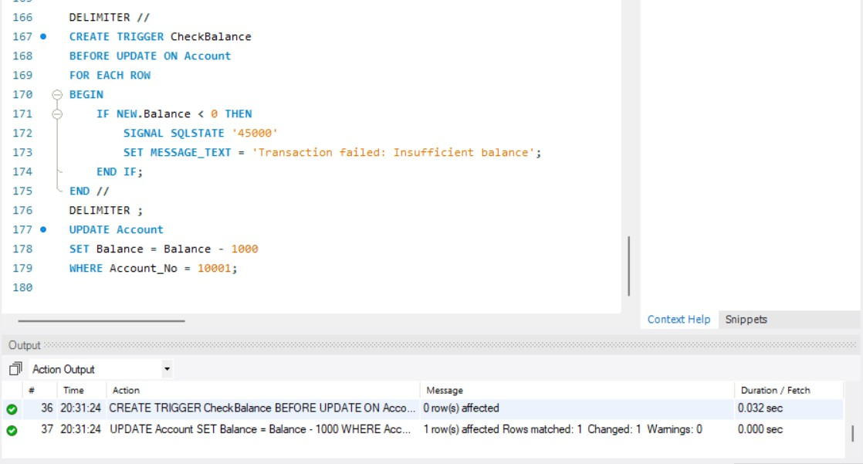

- CREATE TRANSACTION AUDIT TABLE
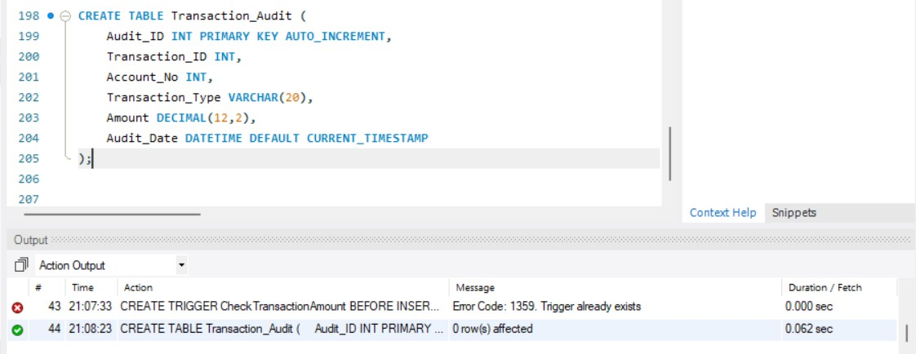
- TRIGGER – TRANSACTION AUDIT
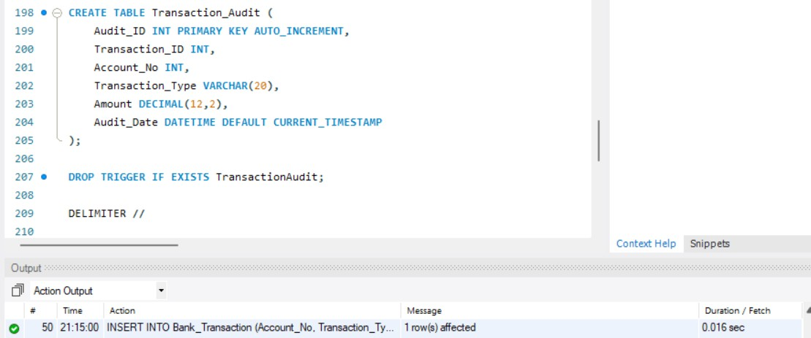

- TRIGGER – TRANSACTION AUDIT
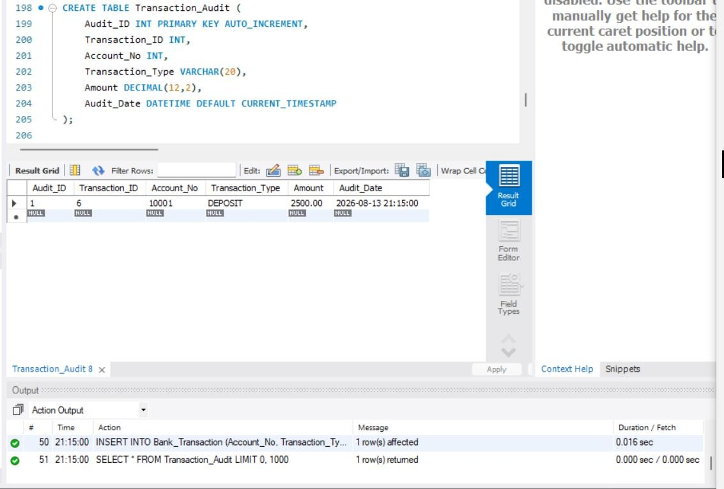
- TRIGGER – AUTOMATICALLY UPDATE ACCOUNT BALANCE
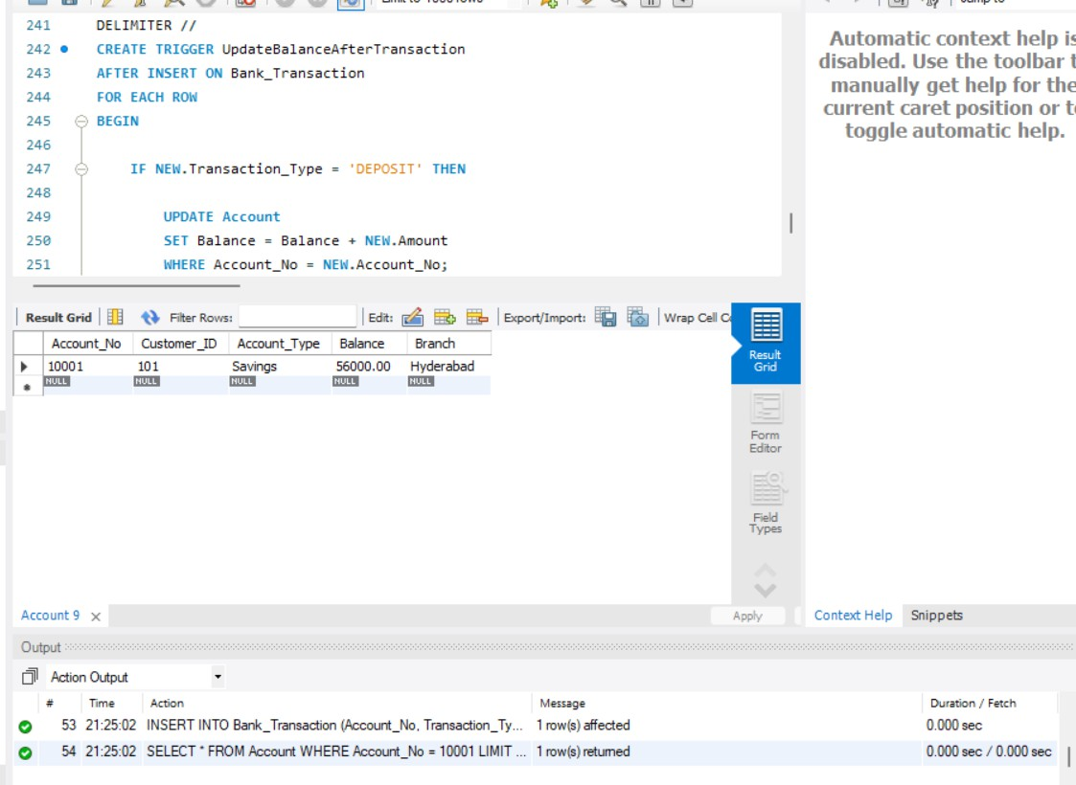

- TRIGGER – PREVENT WITHDRAWAL ABOVE BALANCE

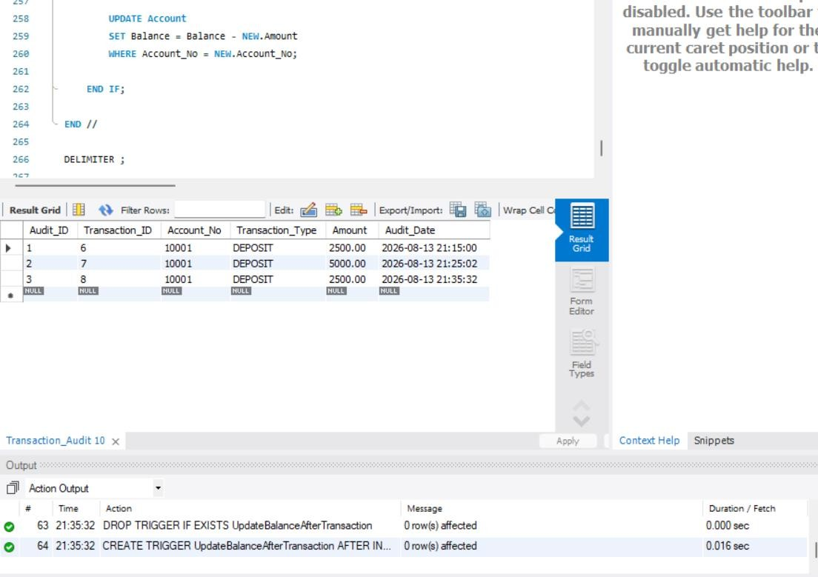
- PROCEDURE – ACCOUNT TRANSFER
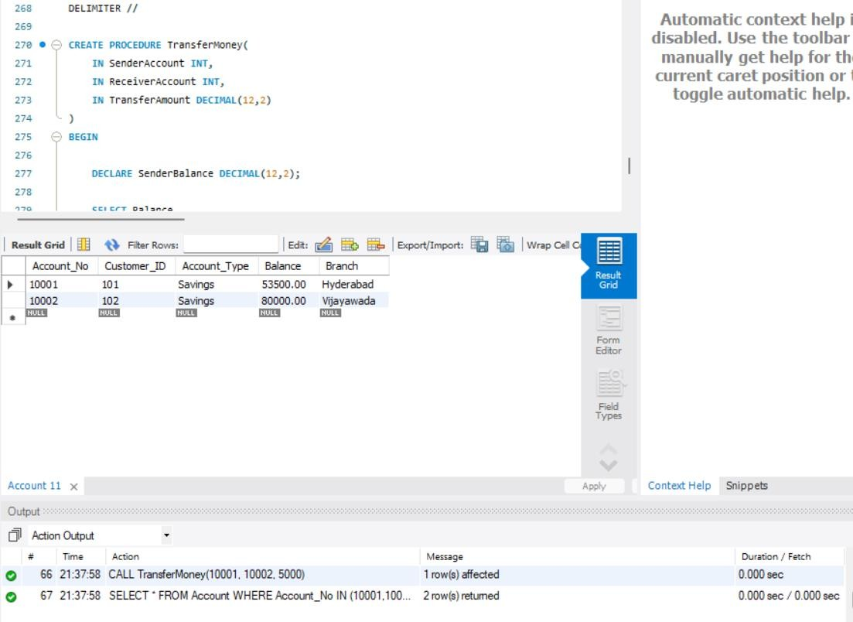

- PROCEDURE – CUSTOMER LOAN DETAILS
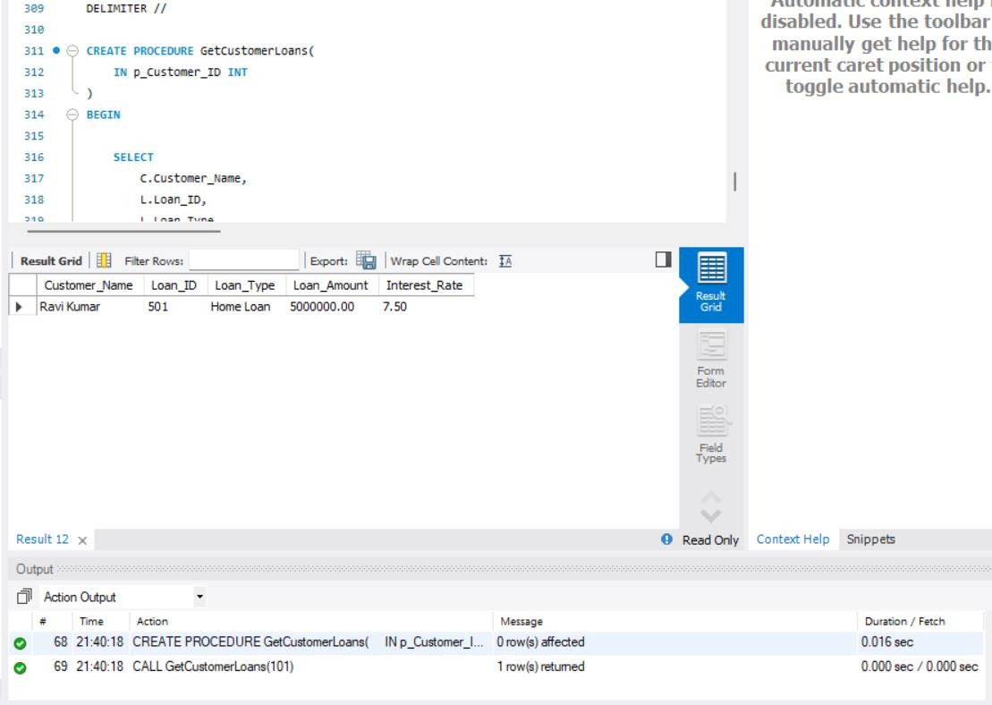
- PROCEDURE – HIGH BALANCE ACCOUNTS
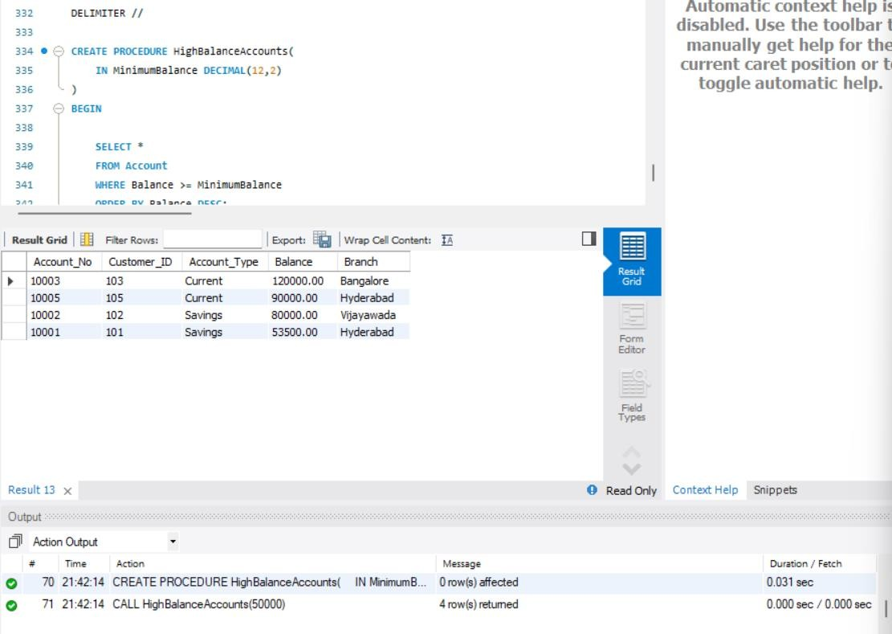

- PROCEDURE WITH IN, OUT PARAMETERS
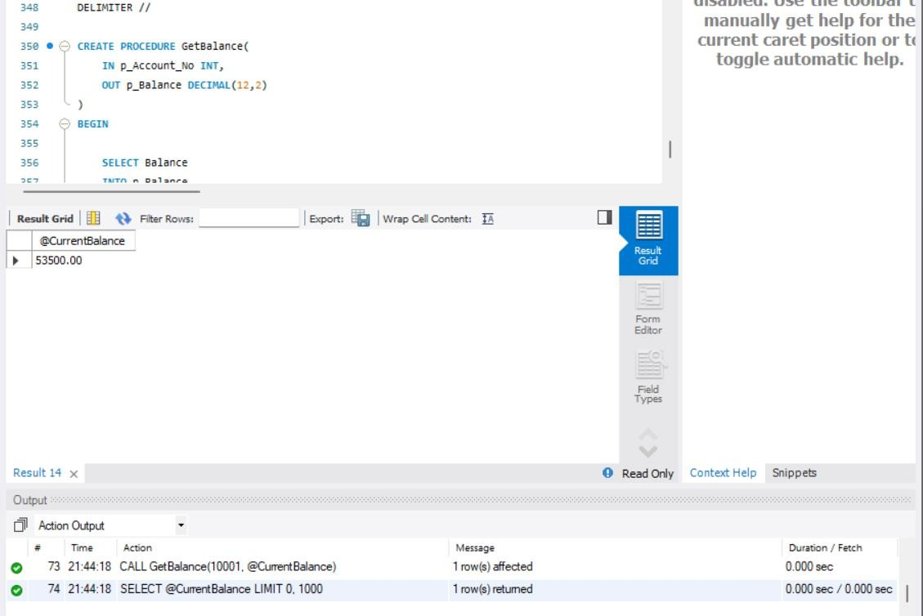
- TRIGGER MANAGEMENT COMMANDS
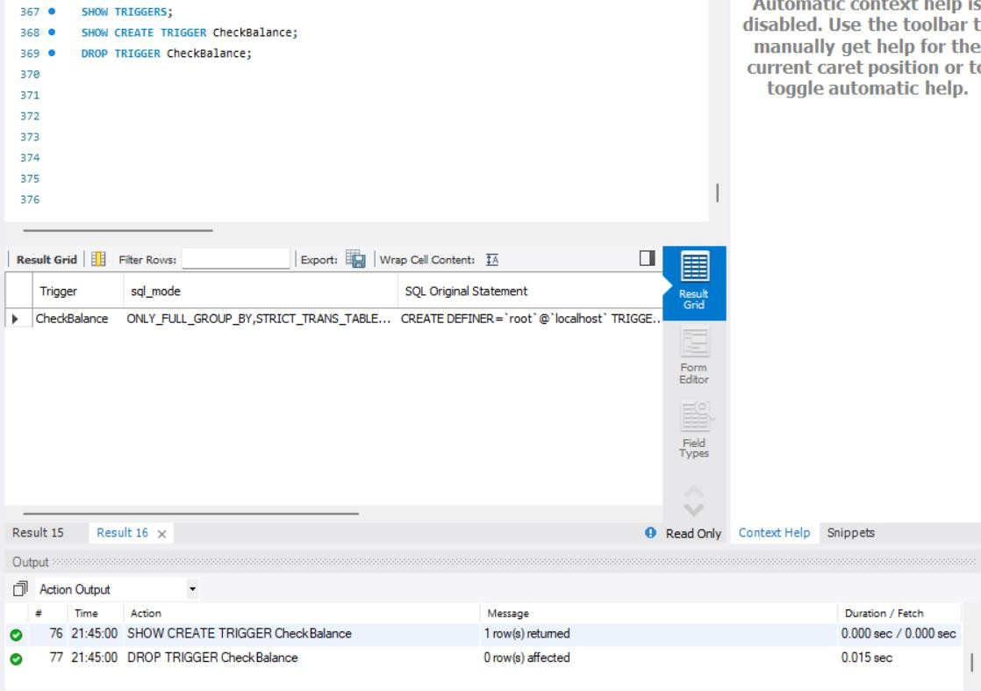

- PROCEDURE MANAGEMENT COMMANDS
